Fog Computing: An Efficient Platform for the Cloud-resource Management
ABSTRACT
Datacenters in cloud paradigm are storing enormous data size, and have an impact on both the energy consumptions as well service costs. Although centralized cloud computing is still more convenient, feasible platform for most of real-time applications and services but not the best. As in centralized distributed environment, resource provision and optimal usage of the configurable resources is somewhat neglected and quality of services are ignored, oversized data communication with low bandwidth network capability leads to the congestion in network data transportation, high latencies, delays and network jitters. Lack of proper resource provisioning leads to the unsophisticated energy management which burdens and laden high energy costs on the end-users. These heavy sized cloud macro data centers have negative impact on the environment as these exchange excessive heat while processing. Recent times marvelous research is being taking place that will provide the new horizons to explore and exploit the new horizons of the distributed technologies. The latest one in the town is the Cisco’s fog-edge computing and is being considered as the next step in the distributed computing paradigm. Here in this paper, we the authors, consider Fog computing as a convenient and an energy efficient computational platform for resource provisioning, and its impact on optimal costs for the computing resources like services and applications.
Existing System
Datacenters in cloud paradigm are storing enormous data size, and have an impact on both the energy consumptions as well service costs. Although centralized cloud computing is still more convenient, feasible platform for most of real-time applications and services but not the best. As in centralized distributed environment, resource provision and optimal usage of the configurable resources is somewhat neglected and quality of services are ignored, oversized data communication with low bandwidth network capability leads to the congestion in network data transportation, high latencies, delays and network jitters
Disadvantages
- data communication with low bandwidth network capability leads to the congestion in network data transportation
- Energy inefficient
Proposed System
In this paper the more attention is on applications running in fog-edge network and are energy efficient compared to same applications and services running over entirely core-cloud centralized network [3]. The efficient energy management model is of importance to monitor and control the energy consumptions. Proliferation in technology paved more opportunities and possibilities to minimize the energy constraints by enabling the portable less power consuming and high performing RFID tagged end devices enable to make energy efficient systems [4]. These systems make possible cost feasibility and portability, reduction in physical shape and size (Sensors, Actuators, Network-adapters, Switches, Routers, and Fog-Smart Gateways) [5]. In this article our motto is to consider and introduce Fog platform as a novel platform for some of cloud constraints like flexibility, interactivity, scalability, and interoperability among various fog-edge devices, lowering the energy management costs
Advantages
- portable less power consuming and high performing RFID tagged end devices enable to make energy efficient systems
- The efficient energy management model is of importance to monitor and control the energy consumptions.
System Architecture

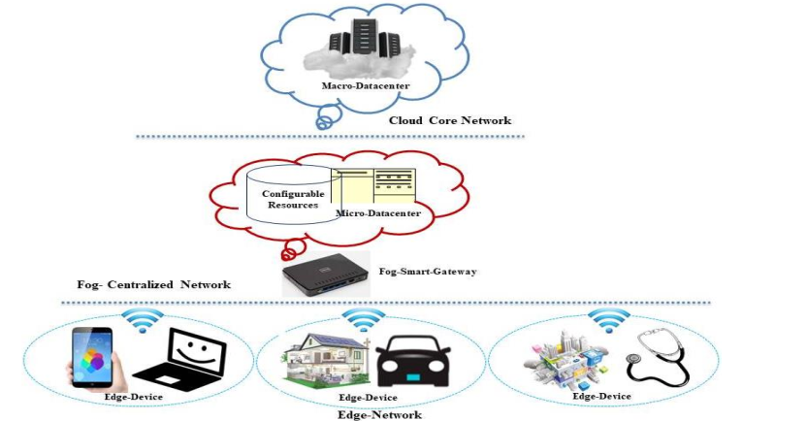
Figure 1: Fog Computing Layered Architecture

Hardware Requirements:

Processor - Pentium –IV
- Speed - 1.1 GHz
- Ram - 256 MB
- Hard Disk - 20 GB
- Key Board - Standard Windows Keyboard
- Mouse - Two or Three Button Mouse
- Monitor - SVGA
Software Requirements:
- Operating System - Windows XP
- Coding Language - Java

